1.installed mongodb in my machine

2. set the system variable path(copy paste the mongo upto bin path)

3. open the cmd and type mongod (it will show create a folder in c-drive data/db)

4.agin type mongod (success)

5.now open another cmd and type mongo (here it will show version 5.0.9)

6.next type in cmd show dbs (it will show admin,config,local)(it will show all the database)

7.type cmd use users;(it will show all users)

8.cmd show dbs (again)(show that user database is not here)

9.db.user.insertone({"name": "shashidhar"}); (inserting a document in db)

10. show dbs; (user database list here)(previsly its not showing but its showing after inserting,now its visible in db)

11. db.user.find(); (list out the all the collection documents)

12. show collections; (it will show collection existing in a database)(here USER is a collection stored in db)

C:\Users\SHASSHAS>mongod

{"t":{"$date":"2022-06-20T22:48:06.605+05:30"},"s":"I", "c":"NETWORK", "id":4915701, "ctx":"-","msg":"Initialized wire specification","attr":{"spec":{"incomingExternalClient":{"minWireVersion":0,"maxWireVersion":13},"incomingInternalClient":{"minWireVersion":0,"maxWireVersion":13},"outgoing":{"minWireVersion":0,"maxWireVersion":13},"isInternalClient":true}}}

{"t":{"$date":"2022-06-20T22:48:07.116+05:30"},"s":"I", "c":"CONTROL", "id":23285, "ctx":"-","msg":"Automatically disabling TLS 1.0, to force-enable TLS 1.0 specify --sslDisabledProtocols 'none'"}

{"t":{"$date":"2022-06-20T22:48:07.121+05:30"},"s":"W", "c":"ASIO", "id":22601, "ctx":"main","msg":"No TransportLayer configured during NetworkInterface startup"}

{"t":{"$date":"2022-06-20T22:48:07.121+05:30"},"s":"I", "c":"NETWORK", "id":4648602, "ctx":"main","msg":"Implicit TCP FastOpen in use."}

{"t":{"$date":"2022-06-20T22:48:07.124+05:30"},"s":"W", "c":"ASIO", "id":22601, "ctx":"main","msg":"No TransportLayer configured during NetworkInterface startup"}

{"t":{"$date":"2022-06-20T22:48:07.124+05:30"},"s":"I", "c":"REPL", "id":5123008, "ctx":"main","msg":"Successfully registered PrimaryOnlyService","attr":{"service":"TenantMigrationDonorService","ns":"config.tenantMigrationDonors"}}

{"t":{"$date":"2022-06-20T22:48:07.124+05:30"},"s":"I", "c":"REPL", "id":5123008, "ctx":"main","msg":"Successfully registered PrimaryOnlyService","attr":{"service":"TenantMigrationRecipientService","ns":"config.tenantMigrationRecipients"}}

{"t":{"$date":"2022-06-20T22:48:07.124+05:30"},"s":"I", "c":"CONTROL", "id":5945603, "ctx":"main","msg":"Multi threading initialized"}

{"t":{"$date":"2022-06-20T22:48:07.128+05:30"},"s":"I", "c":"CONTROL", "id":4615611, "ctx":"initandlisten","msg":"MongoDB starting","attr":{"pid":4628,"port":27017,"dbPath":"C:/data/db/","architecture":"64-bit","host":"INLEN8520050893"}}

{"t":{"$date":"2022-06-20T22:48:07.128+05:30"},"s":"I", "c":"CONTROL", "id":23398, "ctx":"initandlisten","msg":"Target operating system minimum version","attr":{"targetMinOS":"Windows 7/Windows Server 2008 R2"}}

{"t":{"$date":"2022-06-20T22:48:07.128+05:30"},"s":"I", "c":"CONTROL", "id":23403, "ctx":"initandlisten","msg":"Build Info","attr":{"buildInfo":{"version":"5.0.9","gitVersion":"6f7dae919422dcd7f4892c10ff20cdc721ad00e6","modules":[],"allocator":"tcmalloc","environment":{"distmod":"windows","distarch":"x86_64","target_arch":"x86_64"}}}}

{"t":{"$date":"2022-06-20T22:48:07.128+05:30"},"s":"I", "c":"CONTROL", "id":51765, "ctx":"initandlisten","msg":"Operating System","attr":{"os":{"name":"Microsoft Windows 10","version":"10.0 (build 19043)"}}}

{"t":{"$date":"2022-06-20T22:48:07.129+05:30"},"s":"I", "c":"CONTROL", "id":21951, "ctx":"initandlisten","msg":"Options set by command line","attr":{"options":{}}}

{"t":{"$date":"2022-06-20T22:48:07.134+05:30"},"s":"I", "c":"STORAGE", "id":22270, "ctx":"initandlisten","msg":"Storage engine to use detected by data files","attr":{"dbpath":"C:/data/db/","storageEngine":"wiredTiger"}}

{"t":{"$date":"2022-06-20T22:48:07.134+05:30"},"s":"I", "c":"STORAGE", "id":22315, "ctx":"initandlisten","msg":"Opening WiredTiger","attr":{"config":"create,cache_size=7368M,session_max=33000,eviction=(threads_min=4,threads_max=4),config_base=false,statistics=(fast),log=(enabled=true,archive=true,path=journal,compressor=snappy),builtin_extension_config=(zstd=(compression_level=6)),file_manager=(close_idle_time=600,close_scan_interval=10,close_handle_minimum=250),statistics_log=(wait=0),verbose=[recovery_progress,checkpoint_progress,compact_progress],"}}

{"t":{"$date":"2022-06-20T22:48:07.212+05:30"},"s":"I", "c":"STORAGE", "id":22430, "ctx":"initandlisten","msg":"WiredTiger message","attr":{"message":"[1655745487:211272][4628:140703314171216], txn-recover: [WT_VERB_RECOVERY_PROGRESS] Recovering log 1 through 2"}}

{"t":{"$date":"2022-06-20T22:48:07.299+05:30"},"s":"I", "c":"STORAGE", "id":22430, "ctx":"initandlisten","msg":"WiredTiger message","attr":{"message":"[1655745487:299156][4628:140703314171216], txn-recover: [WT_VERB_RECOVERY_PROGRESS] Recovering log 2 through 2"}}

{"t":{"$date":"2022-06-20T22:48:07.357+05:30"},"s":"I", "c":"STORAGE", "id":22430, "ctx":"initandlisten","msg":"WiredTiger message","attr":{"message":"[1655745487:356876][4628:140703314171216], txn-recover: [WT_VERB_RECOVERY_ALL] Main recovery loop: starting at 1/22784 to 2/256"}}

{"t":{"$date":"2022-06-20T22:48:07.497+05:30"},"s":"I", "c":"STORAGE", "id":22430, "ctx":"initandlisten","msg":"WiredTiger message","attr":{"message":"[1655745487:497673][4628:140703314171216], txn-recover: [WT_VERB_RECOVERY_PROGRESS] Recovering log 1 through 2"}}

{"t":{"$date":"2022-06-20T22:48:07.622+05:30"},"s":"I", "c":"STORAGE", "id":22430, "ctx":"initandlisten","msg":"WiredTiger message","attr":{"message":"[1655745487:621358][4628:140703314171216], txn-recover: [WT_VERB_RECOVERY_PROGRESS] Recovering log 2 through 2"}}

{"t":{"$date":"2022-06-20T22:48:07.704+05:30"},"s":"I", "c":"STORAGE", "id":22430, "ctx":"initandlisten","msg":"WiredTiger message","attr":{"message":"[1655745487:703423][4628:140703314171216], txn-recover: [WT_VERB_RECOVERY_ALL] Set global recovery timestamp: (0, 0)"}}

{"t":{"$date":"2022-06-20T22:48:07.704+05:30"},"s":"I", "c":"STORAGE", "id":22430, "ctx":"initandlisten","msg":"WiredTiger message","attr":{"message":"[1655745487:704419][4628:140703314171216], txn-recover: [WT_VERB_RECOVERY_ALL] Set global oldest timestamp: (0, 0)"}}

{"t":{"$date":"2022-06-20T22:48:07.708+05:30"},"s":"I", "c":"STORAGE", "id":22430, "ctx":"initandlisten","msg":"WiredTiger message","attr":{"message":"[1655745487:707337][4628:140703314171216], WT_SESSION.checkpoint: [WT_VERB_CHECKPOINT_PROGRESS] saving checkpoint snapshot min: 1, snapshot max: 1 snapshot count: 0, oldest timestamp: (0, 0) , meta checkpoint timestamp: (0, 0) base write gen: 10"}}

{"t":{"$date":"2022-06-20T22:48:07.718+05:30"},"s":"I", "c":"STORAGE", "id":4795906, "ctx":"initandlisten","msg":"WiredTiger opened","attr":{"durationMillis":584}}

{"t":{"$date":"2022-06-20T22:48:07.719+05:30"},"s":"I", "c":"RECOVERY", "id":23987, "ctx":"initandlisten","msg":"WiredTiger recoveryTimestamp","attr":{"recoveryTimestamp":{"$timestamp":{"t":0,"i":0}}}}

{"t":{"$date":"2022-06-20T22:48:07.724+05:30"},"s":"I", "c":"STORAGE", "id":4366408, "ctx":"initandlisten","msg":"No table logging settings modifications are required for existing WiredTiger tables","attr":{"loggingEnabled":true}}

{"t":{"$date":"2022-06-20T22:48:07.726+05:30"},"s":"I", "c":"STORAGE", "id":22262, "ctx":"initandlisten","msg":"Timestamp monitor starting"}

{"t":{"$date":"2022-06-20T22:48:07.731+05:30"},"s":"W", "c":"CONTROL", "id":22120, "ctx":"initandlisten","msg":"Access control is not enabled for the database. Read and write access to data and configuration is unrestricted","tags":["startupWarnings"]}

{"t":{"$date":"2022-06-20T22:48:07.732+05:30"},"s":"W", "c":"CONTROL", "id":22140, "ctx":"initandlisten","msg":"This server is bound to localhost. Remote systems will be unable to connect to this server. Start the server with --bind_ip <address> to specify which IP addresses it should serve responses from, or with --bind_ip_all to bind to all interfaces. If this behavior is desired, start the server with --bind_ip 127.0.0.1 to disable this warning","tags":["startupWarnings"]}

{"t":{"$date":"2022-06-20T22:48:07.741+05:30"},"s":"I", "c":"NETWORK", "id":4915702, "ctx":"initandlisten","msg":"Updated wire specification","attr":{"oldSpec":{"incomingExternalClient":{"minWireVersion":0,"maxWireVersion":13},"incomingInternalClient":{"minWireVersion":0,"maxWireVersion":13},"outgoing":{"minWireVersion":0,"maxWireVersion":13},"isInternalClient":true},"newSpec":{"incomingExternalClient":{"minWireVersion":0,"maxWireVersion":13},"incomingInternalClient":{"minWireVersion":13,"maxWireVersion":13},"outgoing":{"minWireVersion":13,"maxWireVersion":13},"isInternalClient":true}}}

{"t":{"$date":"2022-06-20T22:48:07.741+05:30"},"s":"I", "c":"STORAGE", "id":5071100, "ctx":"initandlisten","msg":"Clearing temp directory"}

{"t":{"$date":"2022-06-20T22:48:07.742+05:30"},"s":"I", "c":"CONTROL", "id":20536, "ctx":"initandlisten","msg":"Flow Control is enabled on this deployment"}

{"t":{"$date":"2022-06-20T22:48:07.999+05:30"},"s":"I", "c":"FTDC", "id":20625, "ctx":"initandlisten","msg":"Initializing full-time diagnostic data capture","attr":{"dataDirectory":"C:/data/db/diagnostic.data"}}

{"t":{"$date":"2022-06-20T22:48:08.006+05:30"},"s":"I", "c":"REPL", "id":6015317, "ctx":"initandlisten","msg":"Setting new configuration state","attr":{"newState":"ConfigReplicationDisabled","oldState":"ConfigPreStart"}}

{"t":{"$date":"2022-06-20T22:48:08.012+05:30"},"s":"I", "c":"NETWORK", "id":23015, "ctx":"listener","msg":"Listening on","attr":{"address":"127.0.0.1"}}

{"t":{"$date":"2022-06-20T22:48:08.012+05:30"},"s":"I", "c":"NETWORK", "id":23016, "ctx":"listener","msg":"Waiting for connections","attr":{"port":27017,"ssl":"off"}}

C:\Users\SHASSHAS>mongo

MongoDB shell version v5.0.9

connecting to: mongodb://127.0.0.1:27017/?compressors=disabled&gssapiServiceName=mongodb

Implicit session: session { "id" : UUID("9390496f-24ca-4620-97b6-8c2732d6896f") }

MongoDB server version: 5.0.9

================

Warning: the "mongo" shell has been superseded by "mongosh",

which delivers improved usability and compatibility.The "mongo" shell has been deprecated and will be removed in

an upcoming release.

For installation instructions, see

https://docs.mongodb.com/mongodb-shell/install/

================

---

The server generated these startup warnings when booting:

2022-06-20T22:51:00.156+05:30: Access control is not enabled for the database. Read and write access to data and configuration is unrestricted

2022-06-20T22:51:00.157+05:30: This server is bound to localhost. Remote systems will be unable to connect to this server. Start the server with --bind_ip <address> to specify which IP addresses it should serve responses from, or with --bind_ip_all to bind to all interfaces. If this behavior is desired, start the server with --bind_ip 127.0.0.1 to disable this warning

---

---

Enable MongoDB's free cloud-based monitoring service, which will then receive and display

metrics about your deployment (disk utilization, CPU, operation statistics, etc).

The monitoring data will be available on a MongoDB website with a unique URL accessible to you

and anyone you share the URL with. MongoDB may use this information to make product

improvements and to suggest MongoDB products and deployment options to you.

To enable free monitoring, run the following command: db.enableFreeMonitoring()

To permanently disable this reminder, run the following command: db.disableFreeMonitoring()

---

> show dbs;

admin 0.000GB

config 0.000GB

local 0.000GB

> use users;

switched to db users

> show dbs;

admin 0.000GB

config 0.000GB

local 0.000GB

> db.user.insertOne({"name": "shashidhar"});

{

"acknowledged" : true,

"insertedId" : ObjectId("62b0adbdecd90cf195132e83")

}

> show dbs;

admin 0.000GB

config 0.000GB

local 0.000GB

users 0.000GB

> db.user.find();

{ "_id" : ObjectId("62b0adbdecd90cf195132e83"), "name" : "shashidhar" }

> show collections;

user

> db.createCollection('books');

{ "ok" : 1 }

> show dbs

admin 0.000GB

config 0.000GB

local 0.000GB

users 0.000GB

> use users;

switched to db users

> db.books.insert({"title":"Flight Club", " writer":"Chuck Palahniko", "year":"1999"});

WriteResult({ "nInserted" : 1 })

>

Microsoft Windows [Version 10.0.19043.1706]

(c) Microsoft Corporation. All rights reserved.

C:\Users\SHASSHAS>mongo

MongoDB shell version v5.0.9

connecting to: mongodb://127.0.0.1:27017/?compressors=disabled&gssapiServiceName=mongodb

Implicit session: session { "id" : UUID("5c6ed1d9-9238-4da2-a700-71637a03b7c7") }

MongoDB server version: 5.0.9

================

Warning: the "mongo" shell has been superseded by "mongosh",

which delivers improved usability and compatibility.The "mongo" shell has been deprecated and will be removed in

an upcoming release.

For installation instructions, see

https://docs.mongodb.com/mongodb-shell/install/

================

---

The server generated these startup warnings when booting:

2022-06-21T13:36:09.147+05:30: Access control is not enabled for the database. Read and write access to data and configuration is unrestricted

2022-06-21T13:36:09.147+05:30: This server is bound to localhost. Remote systems will be unable to connect to this server. Start the server with --bind_ip <address> to specify which IP addresses it should serve responses from, or with --bind_ip_all to bind to all interfaces. If this behavior is desired, start the server with --bind_ip 127.0.0.1 to disable this warning

---

---

Enable MongoDB's free cloud-based monitoring service, which will then receive and display

metrics about your deployment (disk utilization, CPU, operation statistics, etc).

The monitoring data will be available on a MongoDB website with a unique URL accessible to you

and anyone you share the URL with. MongoDB may use this information to make product

improvements and to suggest MongoDB products and deployment options to you.

To enable free monitoring, run the following command: db.enableFreeMonitoring()

To permanently disable this reminder, run the following command: db.disableFreeMonitoring()

---

> show dbs

admin 0.000GB

config 0.000GB

local 0.000GB

users 0.000GB

> use users;

switched to db users

> db.books.insert({"title":"Flight Club", " writer":"Chuck Palahniko", "year":"1999"});

WriteResult({ "nInserted" : 1 })

> db.createCollection("movies")

{ "ok" : 1 }

>

>

> db.movies.insertMany([{

... title : "Fight Club",

... writer : "Chuck Palahniuko",

... year : 1999,

... actors : [ "Brad Pitt", "Edward Norton" ]

... },

... {

... title : "Pulp Fiction",

... writer : "Quentin Tarantino",

... year : 1994,

... actors : [ "John Travolta", "Uma Thurman" ]

... },{

...

... title : "Inglorious Basterds",

... writer : "Quentin Tarantino",

... year : 2009,

... actors : [ "Brad Pitt", "Diane Kruger", "Eli Roth" ]

... },

... {title : "The Hobbit: An Unexpected Journey",

... writer : "J.R.R. Tolkein",

... year : 2012,

... franchise : "The Hobbit"

...

... },

... {

... title : "The Hobbit: The Desolation of Smaug",

... writer : "J.R.R. Tolkein",

... year : 2013,

... franchise : "The Hobbit"

... },

... {

... title : "The Hobbit: The Battle of the Five Armies",

... writer : "J.R.R. Tolkein",

... year : 2012,

... synopsis : "Bilbo and Company are forced to engage in a war against an array of combatants and keep the Lonely Mountain from falling into the hands of a rising darkness."

... },

... {

... title : "Pee Wee Herman's Big Adventure"

... },

... {

... title : "Avatar"

... }

... ])

{

"acknowledged" : true,

"insertedIds" : [

ObjectId("62b17fc9ef8030bd46582d03"),

ObjectId("62b17fc9ef8030bd46582d04"),

ObjectId("62b17fc9ef8030bd46582d05"),

ObjectId("62b17fc9ef8030bd46582d06"),

ObjectId("62b17fc9ef8030bd46582d07"),

ObjectId("62b17fc9ef8030bd46582d08"),

ObjectId("62b17fc9ef8030bd46582d09"),

ObjectId("62b17fc9ef8030bd46582d0a")

]

}

> db.movies.find()

{ "_id" : ObjectId("62b17fc9ef8030bd46582d03"), "title" : "Fight Club", "writer" : "Chuck Palahniuko", "year" : 1999, "actors" : [ "Brad Pitt", "Edward Norton" ] }

{ "_id" : ObjectId("62b17fc9ef8030bd46582d04"), "title" : "Pulp Fiction", "writer" : "Quentin Tarantino", "year" : 1994, "actors" : [ "John Travolta", "Uma Thurman" ] }

{ "_id" : ObjectId("62b17fc9ef8030bd46582d05"), "title" : "Inglorious Basterds", "writer" : "Quentin Tarantino", "year" : 2009, "actors" : [ "Brad Pitt", "Diane Kruger", "Eli Roth" ] }

{ "_id" : ObjectId("62b17fc9ef8030bd46582d06"), "title" : "The Hobbit: An Unexpected Journey", "writer" : "J.R.R. Tolkein", "year" : 2012, "franchise" : "The Hobbit" }

{ "_id" : ObjectId("62b17fc9ef8030bd46582d07"), "title" : "The Hobbit: The Desolation of Smaug", "writer" : "J.R.R. Tolkein", "year" : 2013, "franchise" : "The Hobbit" }

{ "_id" : ObjectId("62b17fc9ef8030bd46582d08"), "title" : "The Hobbit: The Battle of the Five Armies", "writer" : "J.R.R. Tolkein", "year" : 2012, "synopsis" : "Bilbo and Company are forced to engage in a war against an array of combatants and keep the Lonely Mountain from falling into the hands of a rising darkness." }

{ "_id" : ObjectId("62b17fc9ef8030bd46582d09"), "title" : "Pee Wee Herman's Big Adventure" }

{ "_id" : ObjectId("62b17fc9ef8030bd46582d0a"), "title" : "Avatar" }

>

>

>

>

> db.movies.find({writer:"Quentin Tarantino"})

{ "_id" : ObjectId("62b17fc9ef8030bd46582d04"), "title" : "Pulp Fiction", "writer" : "Quentin Tarantino", "year" : 1994, "actors" : [ "John Travolta", "Uma Thurman" ] }

{ "_id" : ObjectId("62b17fc9ef8030bd46582d05"), "title" : "Inglorious Basterds", "writer" : "Quentin Tarantino", "year" : 2009, "actors" : [ "Brad Pitt", "Diane Kruger", "Eli Roth" ] }

>

>

>

> db.movies.find({actors:"Brad Pitt"})

{ "_id" : ObjectId("62b17fc9ef8030bd46582d03"), "title" : "Fight Club", "writer" : "Chuck Palahniuko", "year" : 1999, "actors" : [ "Brad Pitt", "Edward Norton" ] }

{ "_id" : ObjectId("62b17fc9ef8030bd46582d05"), "title" : "Inglorious Basterds", "writer" : "Quentin Tarantino", "year" : 2009, "actors" : [ "Brad Pitt", "Diane Kruger", "Eli Roth" ] }

>

>

> db.movies.find({franchise:"The Hobbit"})

{ "_id" : ObjectId("62b17fc9ef8030bd46582d06"), "title" : "The Hobbit: An Unexpected Journey", "writer" : "J.R.R. Tolkein", "year" : 2012, "franchise" : "The Hobbit" }

{ "_id" : ObjectId("62b17fc9ef8030bd46582d07"), "title" : "The Hobbit: The Desolation of Smaug", "writer" : "J.R.R. Tolkein", "year" : 2013, "franchise" : "The Hobbit" }

>

>

>

> db.movies.find({$and:[{year:{$gte:1990}},{year:{$lt:2000}}]})

{ "_id" : ObjectId("62b17fc9ef8030bd46582d03"), "title" : "Fight Club", "writer" : "Chuck Palahniuko", "year" : 1999, "actors" : [ "Brad Pitt", "Edward Norton" ] }

{ "_id" : ObjectId("62b17fc9ef8030bd46582d04"), "title" : "Pulp Fiction", "writer" : "Quentin Tarantino", "year" : 1994, "actors" : [ "John Travolta", "Uma Thurman" ] }

>

>

>

> db.movies.find({$or:[{year:{$gte:2010}},{year:{$lt:2000}}]})

{ "_id" : ObjectId("62b17fc9ef8030bd46582d03"), "title" : "Fight Club", "writer" : "Chuck Palahniuko", "year" : 1999, "actors" : [ "Brad Pitt", "Edward Norton" ] }

{ "_id" : ObjectId("62b17fc9ef8030bd46582d04"), "title" : "Pulp Fiction", "writer" : "Quentin Tarantino", "year" : 1994, "actors" : [ "John Travolta", "Uma Thurman" ] }

{ "_id" : ObjectId("62b17fc9ef8030bd46582d06"), "title" : "The Hobbit: An Unexpected Journey", "writer" : "J.R.R. Tolkein", "year" : 2012, "franchise" : "The Hobbit" }

{ "_id" : ObjectId("62b17fc9ef8030bd46582d07"), "title" : "The Hobbit: The Desolation of Smaug", "writer" : "J.R.R. Tolkein", "year" : 2013, "franchise" : "The Hobbit" }

{ "_id" : ObjectId("62b17fc9ef8030bd46582d08"), "title" : "The Hobbit: The Battle of the Five Armies", "writer" : "J.R.R. Tolkein", "year" : 2012, "synopsis" : "Bilbo and Company are forced to engage in a war against an array of combatants and keep the Lonely Mountain from falling into the hands of a rising darkness." }

>

Update document

Text search

Delete document

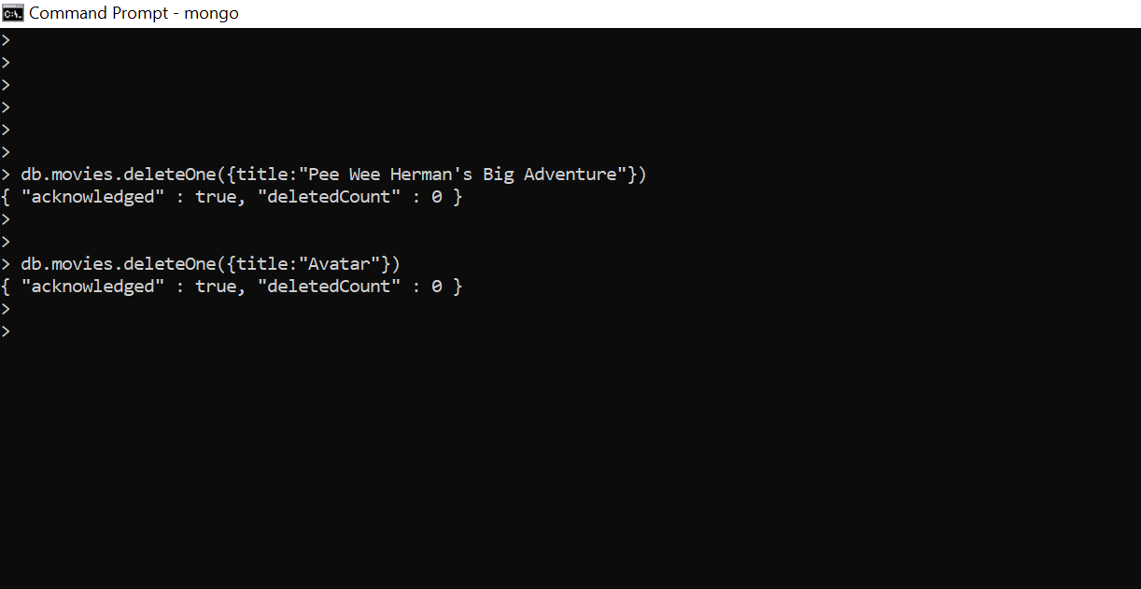

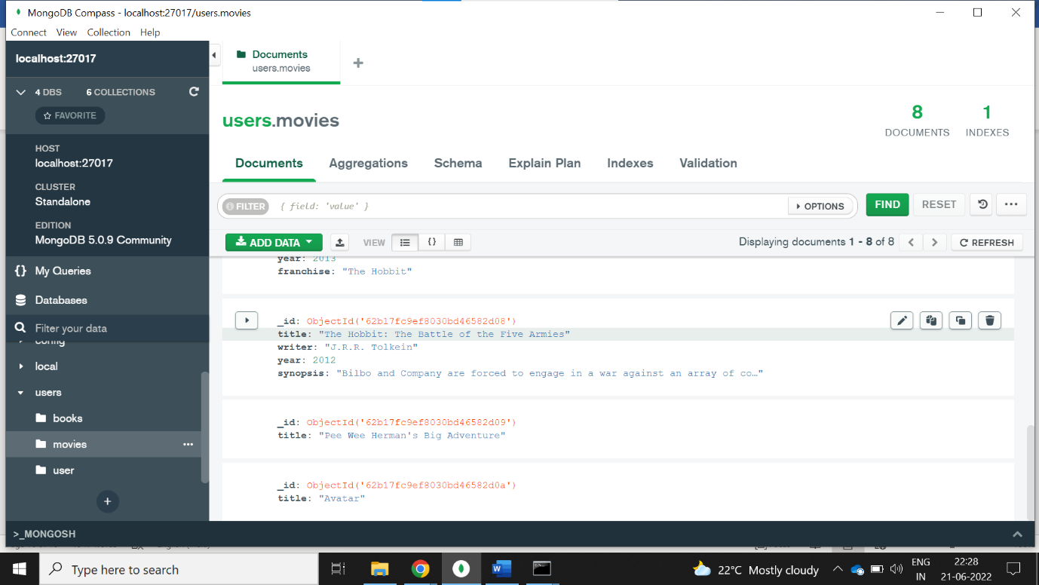

Relationships

